Your image must completely cover the card (this page). The light blue and dark blue must be completely covered.

We print your card 2.75 inches wide by 3.75 inches tall (dark blue – page size)
We then trim to the final size 2.5 inches wide by 3.5 inches tall (light blue)
To ensure critical text or image content does not get cut off in the trimming process, make sure your content is 1/8th inch inside the light blue area. Like this black text.

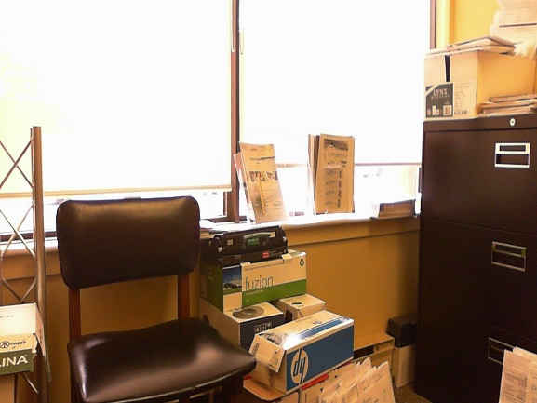
Image Size:
2.75 inches wide
3.75 inches tall
Centered on Page
Make sure ‘Text Wrap’ is set to have the image ‘Behind’ the text

How to Change:
Right click image, and choose ‘Size and Position’

Happy Birthday

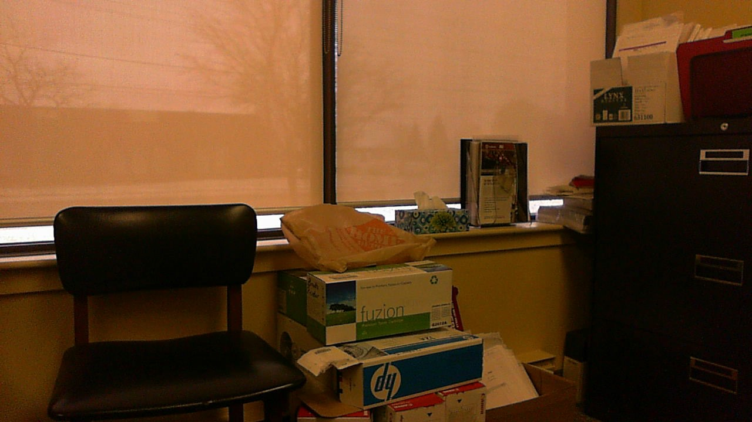
Mom !

